8. Develop a system using UML for Software Personnel Management System. It should be used to process the details of a person who works in a software company. The details are to be stored in the central management system for cross-checking the person’s details.

Class diagram: -

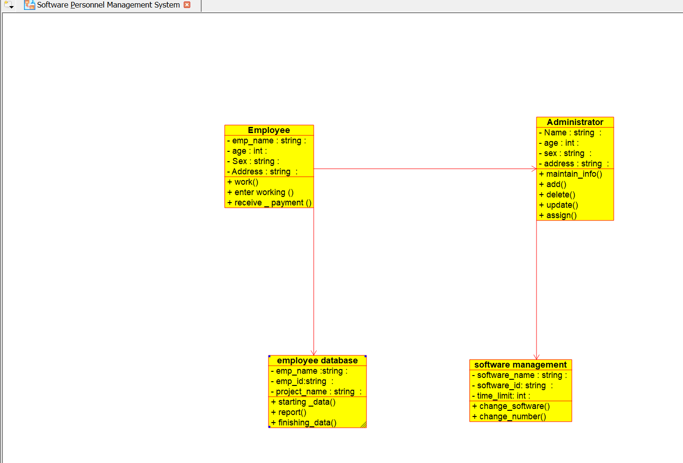

Sequence diagram :-

